**Discussion 1**

You have a dataset containing the recorded daily temperatures for one month. Your task is to determine the number of days within that month where the temperature exceeded 25 degrees Celsius. Briefly describe the steps to Solve the Problem.

**Discussion 2**

What is the output of the following Python program?

value = 6

if value % 2 == 0:

print("first", value)

elif value % 3 == 0:

print("second", value)

while value <= 9:

value = value + 1

if value == 8:

continue

else:

pass

print ("third", value)

else:

print ("fourth", value)

print("fifth", value)

**Discussion 3**

The following program calculates the number of input strings with letter ‘a’, and end the program when the input string is “####”. Here is an expected sample run:

***Sample :***

enter a string (enter #### to stop): apple

enter a string (enter #### to stop): banana

enter a string (enter #### to stop): strawberry

enter a string (enter #### to stop): book

enter a string (enter #### to stop): ####

3 strings with letter 'a'

while True:

str = input("enter a string: ")

for letter in str:

if letter == 'a':

break

count +=1

print(count , "strings with letter 'a'")

There are some errors in the above program. Please indicate where the errors are and how to correct them.

**Discussion 4**

Write a simple Python program to implement the Pseudocode of FizzBuzz problem in discussion #1.

**Discussion 5**

Write a Python program that reads an integer from the user, which is the width of the pattern below, and then prints out the pattern. Suggestion: use nested **for** loops. Hint: **print("*",end="")**.

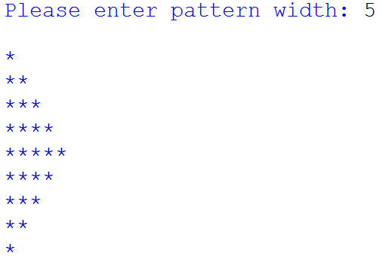

Further discussion: Is it possible to use **for** only twice? Or even once? (of course no **while**)